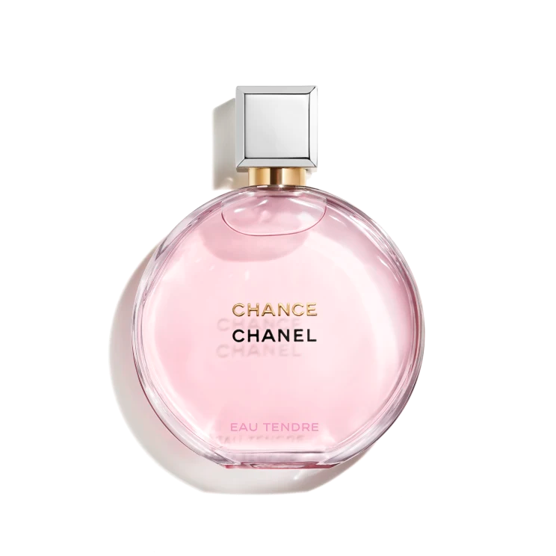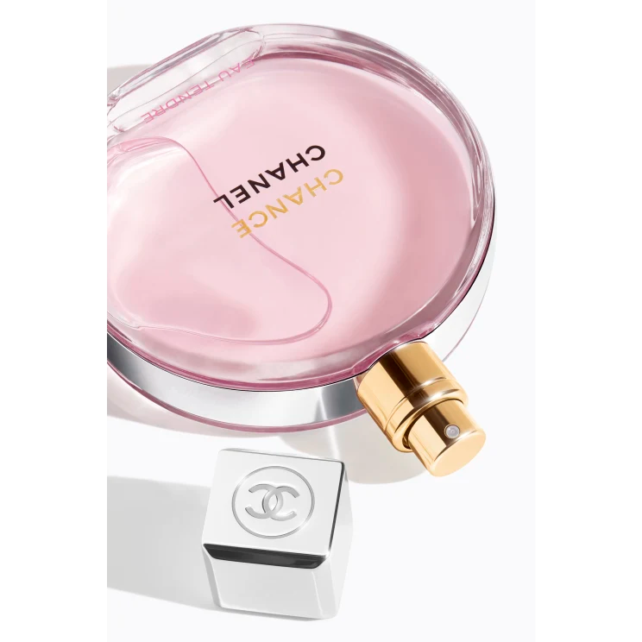

**CHANCE EAU TENDRE**

**$165**

Tax Included.

Spray 100 mL

IN STOCK

**Product Details**

An enhanced interpretation of the unexpected floral-fruity fragrance, CHANCE EAU TENDRE Eau de Parfum possesses a tender, delicate presence that sweeps you into a whirlwind of happiness and fantasy—a chance encounter. A dazzling constellation of notes is intensified by jasmine absolute and rose essence. An intoxicatingly soft and enveloping trail unfurls for a radiant and feminine scent.